

CSI OT 3D Platform Cyber Attack Demonstration SCADA HMI

SCADA HMI Design Manual

VERSION: CORPLAB-2021-T5F-A1

30/03/2021

Prepared by

Liu Yuancheng

Senior Security Development Engineer

[yuancheng.liu@trustwave.com](https://nusu-my.sharepoint.com/personal/dcsshch_nus_edu_sg/Documents/Work%20Related%20Files/Singtel%20OT%20Training/yuancheng.liu@trustwave.com)

Wong Jun Wen

Asst R&D Manager

[junwen.wong@trustwave.com](https://nusu-my.sharepoint.com/personal/dcsshch_nus_edu_sg/Documents/Work%20Related%20Files/Singtel%20OT%20Training/junwen.wong@trustwave.com)

Dr. Shantanu Chakrabarty

NUS Research Fellow

[shantanu1088@gmail.com](https://nusu-my.sharepoint.com/personal/dcsshch_nus_edu_sg/Documents/Work%20Related%20Files/Singtel%20OT%20Training/shantanu1088@gmail.com)

Confidentiality Notice: This document is confidential and contains proprietary information and intellectual property of Trustwave, a Singtel company, its parent company and its subsidiaries. Neither this document nor any of the information contained herein may be reproduced or disclosed under any circumstances. Please be aware that disclosure, copying, distribution or use of this document and the information contained therein is strictly prohibited.

**CSI OT 3D Platform Cyber Attack Demonstration SCADA HMI Design Manual**

**1.Project Introduction**

This project will implement a Supervisory control and data acquisition (SCADA) Human-machine interface (HMI) program to control the main components on the CSI OT-3D Platform. we will create 2 kinds of SCADA HMI system with schneider wonderware(R) program and python for the user to control the PLC railway modules or simulate different railway operation for training or research purpose. The wonderware HMI program are mainly used for the demo purpose, it contents three main pages:

* Training SCADA HMI page used for training and demonstration for the whole system.
* PLC Status View HMI page are using the for the working flow logic of the PLCs modules in the system.
* Railway Command and Control HMI page is used to simulate and demonstrate the railway command control centre’s operational sequence.

The wonderware HMI Program will be shown in the SCADA PC in the system with duplicate screen display as shown below:

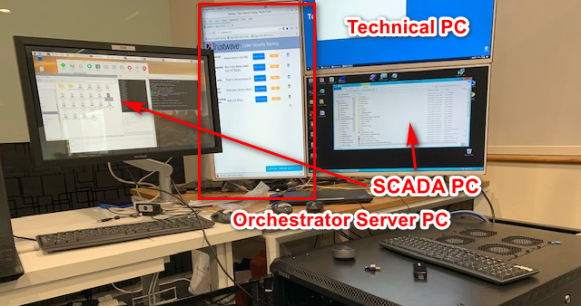

The Development and Debug HMI is created by Python. This program is used for showing the developer the deeper/lower-level debug information during the system is running. I can also simulation some extend function which is not provide by the 3D-Platform hardware for further development. It will also be used for simulating the 3 kinds of cyber-attack situation launched from hacker for the system.

The python HMI can run on any computer which plug in to the system with the IP setup to 192.168.10.150 to 192.168.10.170.

* 1. **Training SCADA HMI Page**

**HMI Page view:**

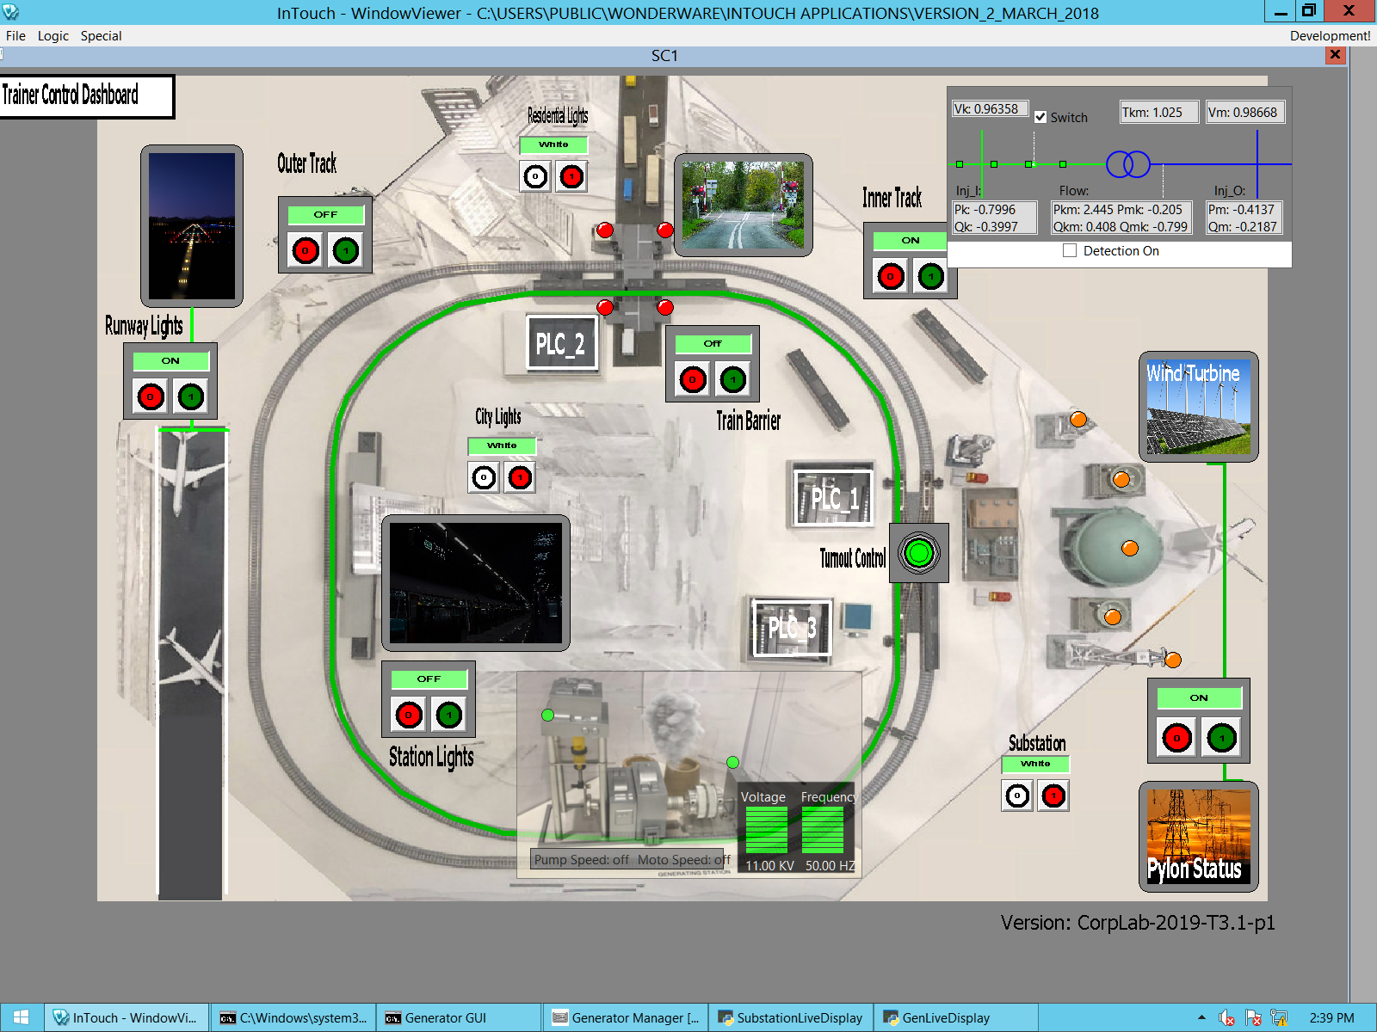

The page is made based on the top view of the 3D platform system by added the control buttons and indicators at the real position of the image as shown below.

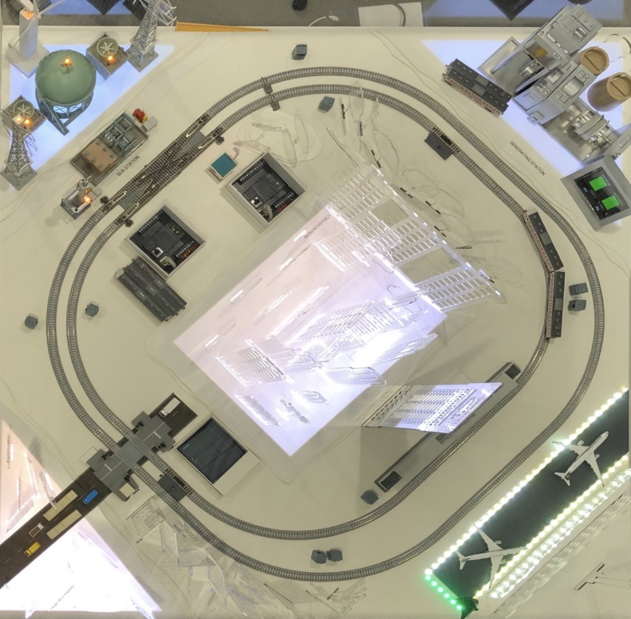1.1.1 Control buttons: the component power is controlled by the button (red and green colour) with on/off label near it:

* Runway light on/off.
* Outer railway track power on/off.
* Train Station power on/off ctrl.
* City lights colour white/red ctrl.
* Industrial Area background lights colour white/red control.
* Train barrier power control.
* Inner railway track power on/off.
* Inner/outer track fork switch ctrl.
* Substation indicator on/off ctrl.
* Substation light background colour while/red control

1.1.2 Camera view window

There five camera simulation view windows for airport, substation, train barrier, wind turbine and pylon station will show the different image view based on the current component state.

1.1.3 State indicators

Runway light indicator: outline and base line will appear when the power is on.

Barrier indicator: four dot indicators will change to red when the barrier at down block position, change to green when the barrier at up position.

City, Industrial and Residential area background indicator: The outline of the area will change to red and flash if the red button was pressed, otherwise the outline will now show.

Railway track indicator: the railway will change to green colour if the track’s power is on.

Railway track toggle indicator: a link line will be shown under the fork toggle switch to link 2 tracks if the fork switch is on.

Power Substation indicator: the five dots indicator will change to orange colour if the power substation’s power is on.

1.1.4 Control button, view window and Indicator position view:

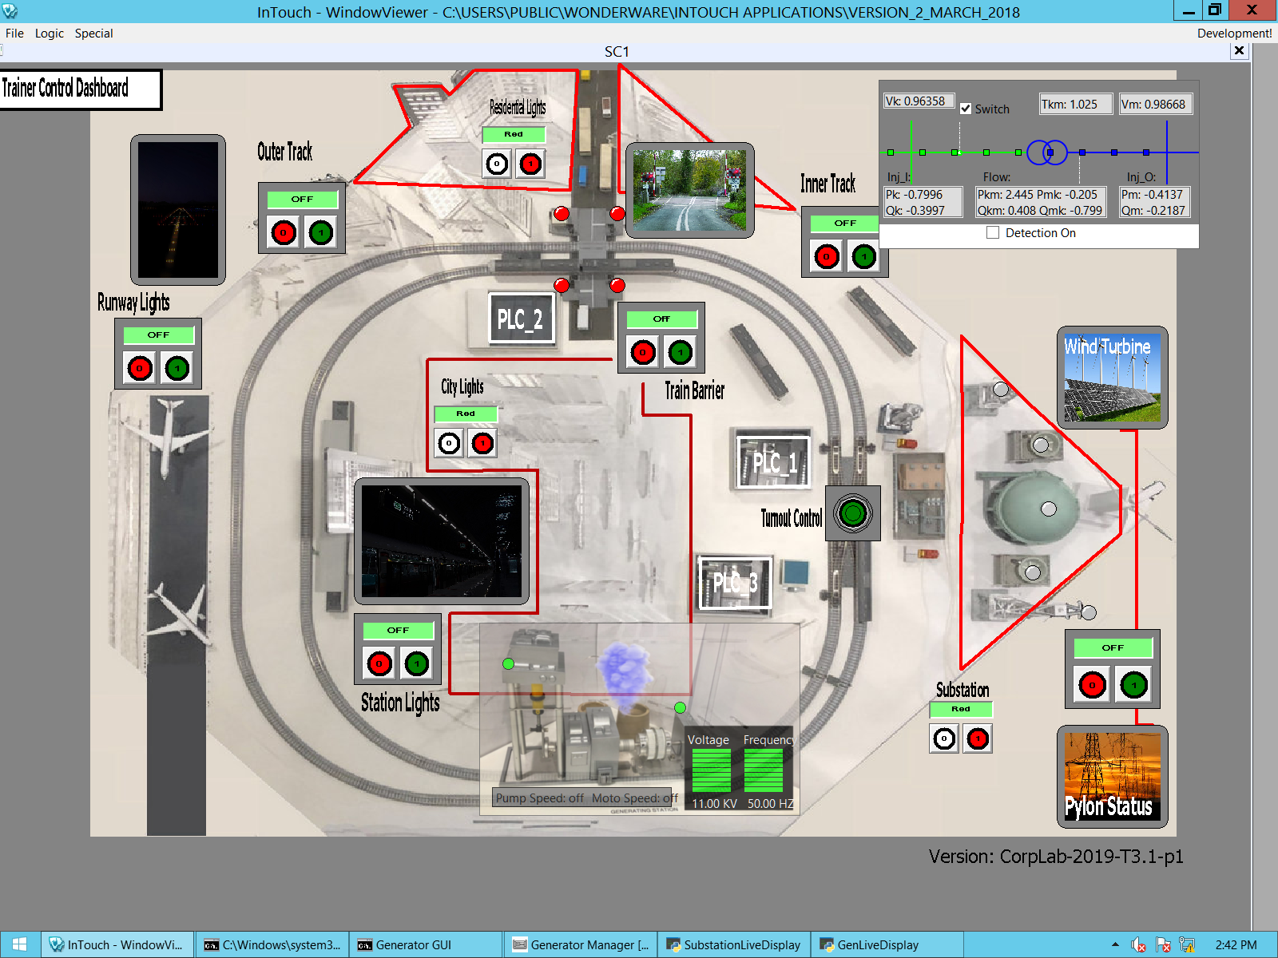

1.1.5 Active the Training HMI page: Double Click the InTouch icon on the desktop => File => View => check the “Page 1” checkout box in the pop up window.